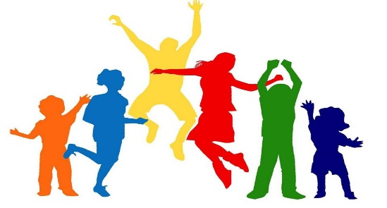
Together Educate Advocate Motivate

I believe that passionate leaders who join together have the potential to impact our profession and the health and wellness of our society. I believe we are stronger together, using each individual’s strengths to create a team that has a greater reach and impact.

I believe we learn from one another and together we can better educate our students and the community concerning healthy lifestyle behaviors. We as educators have the potential to touch the lives of everyone around us…colleagues, students, parents, community members, and the list goes on.

I believe it is our responsibility to advocate for health and wellness in our communities. Our work should impact our State, Region and Nation. We must reach out to key stakeholders and decision makers advocating for our profession. It is imperative that we work within our professional organizations to better leverage our ability to advocate for the health and wellness of future generations.

I believe we are created with gifts that are to be used for the greater good. Our strengths can be used to motivate those around us and we in return are motivated to continue to fight for a healthy, safe and well society.

I believe that I have the skills to help lead the Central District TEAM to further impact the life of our students, teachers and communities.

